Sino-UK University Partnership Programmes Promotion Events

HOPE helped several UK and China universities established cooperation programmes. Recently, these programmes have started to promote for the 2023 entry. International Officers from UK universities gave online presentation to all these China universities’ students who were interested in these programmes. As we can see, more students attended the webinar than past two years while the severe Covid situation spread in the world.

- Loughborough University & Shanghai Sports University
Postgraduate 1+1+1 programme
Time: 20th Oct, 2022



- East China University of Science and Technology & Goldsmiths, University of London
Study Abroad Programme
Time: 25th Oct, 2022
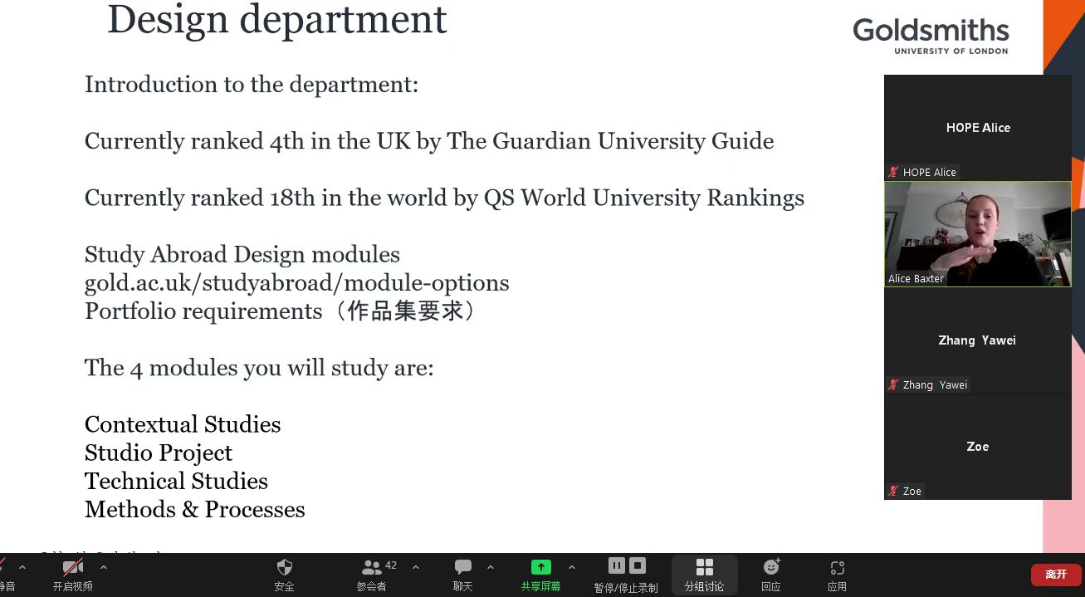

- University of Essex & Shanghai Dianji University
Study Abroad Programme
Time: 8thNov, 2022


In addition, Loughborough University & Zhongnan University of Economics and Law , Loughborough University & Shanghai International Studies University also held information session on Sept and Nov separately.

